**Detecting Fire Combustion in Forests**

**1. Introduction**

**1.1 Overview**

The "Satellite-Based Forest Fire Detection and Prediction System" is a comprehensive initiative aimed at leveraging satellite technology to enhance the early detection and prediction of forest fires. This project seeks to address the pressing issue of forest fires in the United States by utilizing cutting-edge satellite technology for real-time monitoring and analysis.

1. Early Detection: Develop algorithms and systems for early detection of forest fires using satellite data, specifically focusing on heat anomaly and smoke plume detection.

2. Continuous Monitoring : Establish a system for continuous monitoring of forested areas across the United States using a network of dedicated satellites.

3. Data Integration : Integrate satellite data with other relevant data sources, including weather data, topographical data, and historical fire records, to improve prediction accuracy.

4. Rapid Response : Create a real-time alert and notification system that relays fire information to local fire authorities for swift response.

5. Post-Fire Assessment : Develop tools and methodologies for assessing the extent of damage caused by forest fires and aiding in rehabilitation efforts.

6. Research and Analysis : Conduct research to better understand the patterns and causes of forest fires, enabling data-driven strategies for prevention and management.

Project Phases :

1. Planning and Research : In this initial phase, project stakeholders will conduct a thorough review of existing technologies, data sources, and fire management strategies. Research on satellite sensors and data analysis algorithms will be undertaken.

2. System Development : The project will move into the development phase, where the satellite-based detection and prediction system will be designed and built. This includes the creation of algorithms for real-time fire detection.

3. Testing and Validation : Rigorous testing and validation will be conducted to ensure the system's accuracy and reliability. This phase may involve simulated fire scenarios and real-world testing.

4. Deployment : Once validated, the system will be deployed, with satellites actively monitoring forested regions across the United States.

5. Data Integration and Notification : The integration of data sources and the establishment of a notification system will take place during this phase, ensuring that relevant authorities receive timely alerts.

6. Monitoring and Research : Continuous monitoring of the system's performance will occur, alongside ongoing research to refine fire prediction models and improve response strategies.

7. Post-Fire Assessment : Tools for post-fire assessment will be developed and implemented to aid in recovery and rehabilitation efforts.

**1.2 Purpose**

The "Detecting Fire Combustion in Forests" project is dedicated to developing an advanced system for the early detection of fire combustion in forested areas. The primary purposes of this project include:

1. Early Fire Combustion Detection : The project's core purpose is to create a robust system capable of detecting the initial stages of fire combustion in forested regions. Early detection is paramount for timely response and containment.

2. Minimizing Fire Spread : By identifying fire combustion at its inception, the project aims to minimize the spread of fires, reducing their overall impact on forests and neighboring communities.

3. Reducing Environmental Impact : Forest fires can have devastating ecological consequences. The project's purpose includes safeguarding natural ecosystems by promptly identifying and addressing combustion events.

4. Enhancing Safety : Ensuring the safety of nearby residents, wildlife, and firefighting personnel is a critical goal. Early detection enables quicker responses to protect lives and property.

5. Real-Time Monitoring : The project will create a real-time monitoring system that continuously analyzes environmental data and sensor inputs to identify signs of fire combustion.

6. Data-Driven Alerting : The project's algorithms and technology enable data-driven alerting and notifications to relevant authorities, facilitating rapid response and decision-making.

7. Environmental Conservation : By swiftly identifying fire combustion in forests, the project aligns with environmental conservation efforts, safeguarding natural resources and biodiversity.

8. Technological Advancement : Ongoing research and development efforts will advance the technology used for fire combustion detection, potentially improving the accuracy and speed of detection.

9. Community Safety : The project serves the purpose of enhancing the safety of communities located near forested areas by providing an early warning system and facilitating proactive fire management.

In summary, the "Detecting Fire Combustion in Forests" project is focused on developing a sophisticated system for the early detection of fire combustion in forested environments. Its primary objectives are to minimize fire spread, protect ecosystems, ensure community safety, and employ advanced technology to improve fire detection accuracy and speed.

**2. Literature Survey**

**2.1 Existing problem**

Detecting fire combustion in forests is a critical problem, and several existing approaches and methods have been developed to address it. These methods vary in their technology, data sources, and detection techniques. Here are some of the common existing approaches for solving this problem:

1. Remote Sensing Satellites : Satellite-based remote sensing is one of the most widely used methods for detecting forest fires. Specialized satellites equipped with thermal infrared sensors can detect heat anomalies indicative of fire. Examples include NASA's MODIS (Moderate Resolution Imaging Spectroradiometer) and NOAA's GOES (Geostationary Operational Environmental Satellite) systems.

2. Aerial Surveillance : Aircraft equipped with thermal cameras and other sensors are used for aerial surveillance of forested areas. They can provide high-resolution imagery and real-time monitoring capabilities.

3. Ground-Based Sensors : Ground-based sensors, such as weather stations and fire towers, can detect environmental conditions conducive to fire, such as high temperatures, low humidity, and strong winds. These sensors can trigger alerts when specific thresholds are crossed.

4. Camera-Based Systems : Deploying cameras with computer vision technology in forested areas allows for real-time monitoring. These cameras can identify smoke, flames, or heat sources and send alerts when fire combustion is detected.

5. Unmanned Aerial Vehicles (Drones) : Drones equipped with thermal cameras and other sensors can provide aerial views of forested areas and detect fire outbreaks quickly. They are especially useful for monitoring difficult-to-reach or remote locations.

6. Machine Learning Algorithms : Machine learning techniques, including deep learning, are employed to analyze satellite imagery, video feeds, and sensor data to detect fire combustion patterns. These algorithms can learn to differentiate between normal conditions and fire events.

7. Meteorological Data : Weather and meteorological data are crucial for fire prediction. Factors like wind speed and direction, temperature, humidity, and precipitation patterns can be used to assess fire risk and predict fire behavior.

8. Historical Data Analysis : Analyzing historical fire data, including the location, frequency, and severity of past fires, can help identify high-risk areas and periods for fire combustion.

9. Community Reporting : Citizen engagement through mobile apps and websites allows individuals to report potential fires. Crowdsourced data can supplement official monitoring systems.

10. Wireless Sensor Networks : Deploying networks of wireless sensors throughout forested areas allows for real-time data collection and communication. These sensors can measure temperature, humidity, and other relevant parameters.

11. Early Warning Systems : Integrated systems that combine data from multiple sources, including satellites, sensors, and weather data, can provide early warning alerts to relevant authorities and communities.

12. GIS (Geographic Information Systems) : GIS technology is used to map fire-prone areas and predict fire spread based on topography, fuel load, and weather conditions.

13. Fire Behavior Models : Fire behavior models use mathematical equations to simulate fire spread based on various factors, helping predict fire behavior under different conditions.

Effective fire detection and prediction often involve the integration of multiple approaches and data sources to improve accuracy and reduce false alarms. These methods play a crucial role in managing and mitigating the impact of forest fires. Advances in technology and data analytics continue to improve the accuracy and timeliness of fire detection and prediction systems.

**2.2 Proposed Solution**

The proposed solution for "Detecting Fire Combustion in Forests" would involve developing a comprehensive system that combines various technologies and data sources to achieve early and accurate detection of fire combustion in forested areas. Here's an outline of the proposed solution:

Operation Workflow :

1. Data Collection : Cameras, drones, and satellites continuously capture imagery and data. Ground-based sensors provide meteorological data in real-time.

2. Data Analysis : Machine learning algorithms analyze the collected data, identifying potential fire combustion events. These algorithms are trained to distinguish between normal conditions and fire signatures.

3. Alert Generation : When a potential fire combustion event is detected, the system generates an alert, including the location and severity of the event.

4. Notification and Response : Alerts are sent to relevant authorities, such as local fire departments and emergency management agencies, as well as to communities in the affected areas. This facilitates rapid response.

5. Real-Time Monitoring : Continuous monitoring allows the system to track the progression of fires and update predictions as conditions change.

Key Benefits :

- Early Detection : The proposed solution aims to detect fire combustion at its earliest stages, minimizing the time it takes to respond.

- Reduced False Alarms : Machine learning algorithms improve the accuracy of fire detection, reducing false alarms and allowing authorities to allocate resources more efficiently.

- Timely Response : Rapid notification and real-time monitoring enable swift response, helping contain fires before they spread extensively.

- Environmental Protection : By detecting fires early, the solution helps protect natural ecosystems and reduce ecological damage.

- Community Safety : Early warnings and timely responses enhance the safety of residents in fire-prone areas.

- Data-Driven Decisions : Authorities can make informed decisions based on real-time data, improving firefighting strategies and resource allocation.

- Scalability : The system can be scaled to cover large forested areas and adapted to various geographical and environmental conditions.

In summary, the proposed solution for "Detecting Fire Combustion in Forests" combines camera-based surveillance, drones, satellites, machine learning, and real-time data analysis to achieve early and accurate fire detection. It emphasizes timely notification and response to protect both the environment and human lives in fire-prone regions.

**3. Theoretical Analysis**

**3.1 Block Diagram**

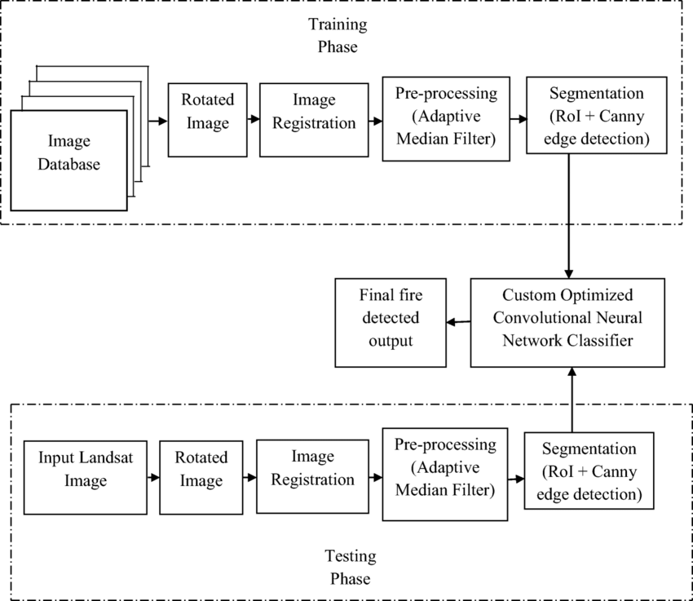

**3.2 Hardware / Software Design**

* **Base software**: ENVI 5.7 and the ENVI Deep Learning 2.1 module
* **Operating systems**:
  + Windows 10 and 11 (Intel/AMD 64-bit)
  + Linux (Intel/AMD 64-bit, kernel 3.10.0 or higher, glibc 2.17 or higher)
* **Hardware**:
  + NVIDIA graphics card with CUDA Compute Capability version 3.5 to 8.6. See the list of [CUDA-enabled GPU cards](https://developer.nvidia.com/cuda-gpus). A minimum of 8 GB of GPU memory is recommended for optimal performance, particularly when training deep learning models.
  + [NVIDIA GPU driver](https://www.nvidia.com/Download/index.aspx?lang=en-us) version: Windows 461.33 or higher, Linux 460.32.03 or higher.
  + A CPU with the Advanced Vector Extensions (AVX) instruction set. In general, any CPU after 2011 will contain this instruction set.
  + Intel CPUs are recommended, though not required. They have an optimized Intel Machine Learning library that offers performance gains for certain Machine Learning algorithms.

**4. Experimental Investigations**

When working on a solution for detecting fire combustion in forests, an in-depth analysis and investigation of various factors and aspects are crucial to design an effective and reliable system. Here are some key areas of analysis and investigation typically conducted during the development of such a system:

1. Environmental Conditions Analysis :

- Study historical weather and climate data for the target forested areas to understand typical fire-prone conditions.

- Analyze temperature patterns, humidity levels, wind speeds, and wind directions to identify factors contributing to fire risk.

2. Data Sources Evaluation :

- Investigate the availability and reliability of data sources, including satellite imagery, ground-based sensors, and weather forecasts.

- Assess the coverage and resolution of satellite data to determine its suitability for early detection and prediction.

3. Technological Feasibility :

- Evaluate the feasibility of deploying cameras, drones, and ground-based sensors in the forested areas, considering factors like accessibility and maintenance requirements.

- Investigate the capabilities of thermal imaging cameras and drones for fire detection.

4. Machine Learning Algorithm Research :

- Research and experiment with different machine learning algorithms, such as convolutional neural networks (CNNs) or recurrent neural networks (RNNs), for fire detection and prediction.

- Investigate the availability of labeled datasets for training machine learning models.

5. Data Integration and Fusion :

- Analyze the integration of data from multiple sources, including satellite, camera feeds, and ground sensors, to ensure seamless data fusion.

- Investigate methods for real-time data synchronization and data quality assurance.

6. Communication Infrastructure Assessment :

- Assess the communication infrastructure required to transmit data from remote forested areas to the central processing system.

- Investigate options for data transmission, such as wireless networks or satellite communication.

7. Geospatial Analysis :

- Perform geospatial analysis to identify high-risk areas within the forested regions based on topography, fuel load, and historical fire data.

- Investigate the use of geographic information systems (GIS) for mapping and spatial analysis.

8. Regulatory and Compliance Considerations :

- Investigate local regulations and compliance requirements related to the deployment of surveillance equipment, data privacy, and emergency response procedures.

9. Alerting and Notification Protocols :

- Investigate the protocols and standards for alert generation and notification, ensuring timely communication with relevant authorities and communities.

10. User Interface and User Experience (UI/UX) Design :

- Conduct user research to understand the needs and preferences of system operators and emergency responders.

- Investigate best practices in UI/UX design for creating a user-friendly monitoring interface.

11. Testing and Validation :

- Develop testing protocols and conduct rigorous testing and validation of the system, including simulated fire scenarios and real-world testing.

- Investigate the system's accuracy, sensitivity, and false alarm rates.

12. Security and Privacy Assessment :

- Investigate cybersecurity measures to protect the system from hacking and unauthorized access.

- Ensure compliance with data privacy regulations when handling sensitive information.

13. Scalability and Sustainability :

- Investigate the scalability of the system to cover larger areas or adapt to changing environmental conditions.

- Analyze the long-term sustainability and maintenance requirements of the hardware and software components.

Throughout the development process, continuous investigation and analysis are essential to refine the system's performance, accuracy, and effectiveness in detecting and predicting forest fires. Collaboration with experts in meteorology, forestry, and fire management can also provide valuable insights and guidance during the investigation and analysis phases

**5. Flowchart**.

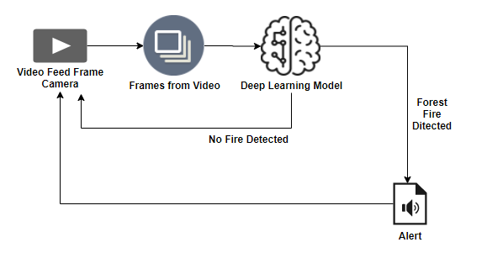

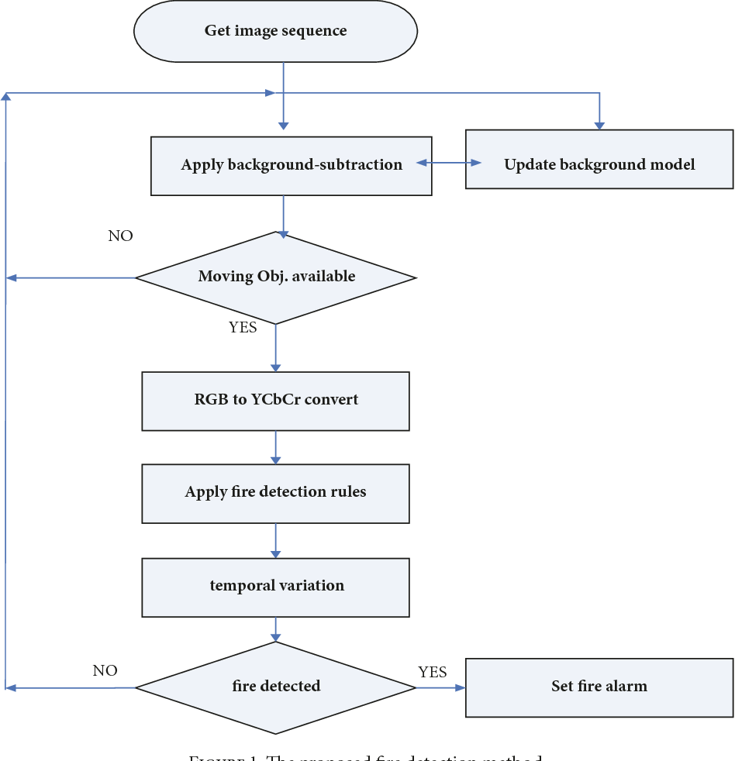

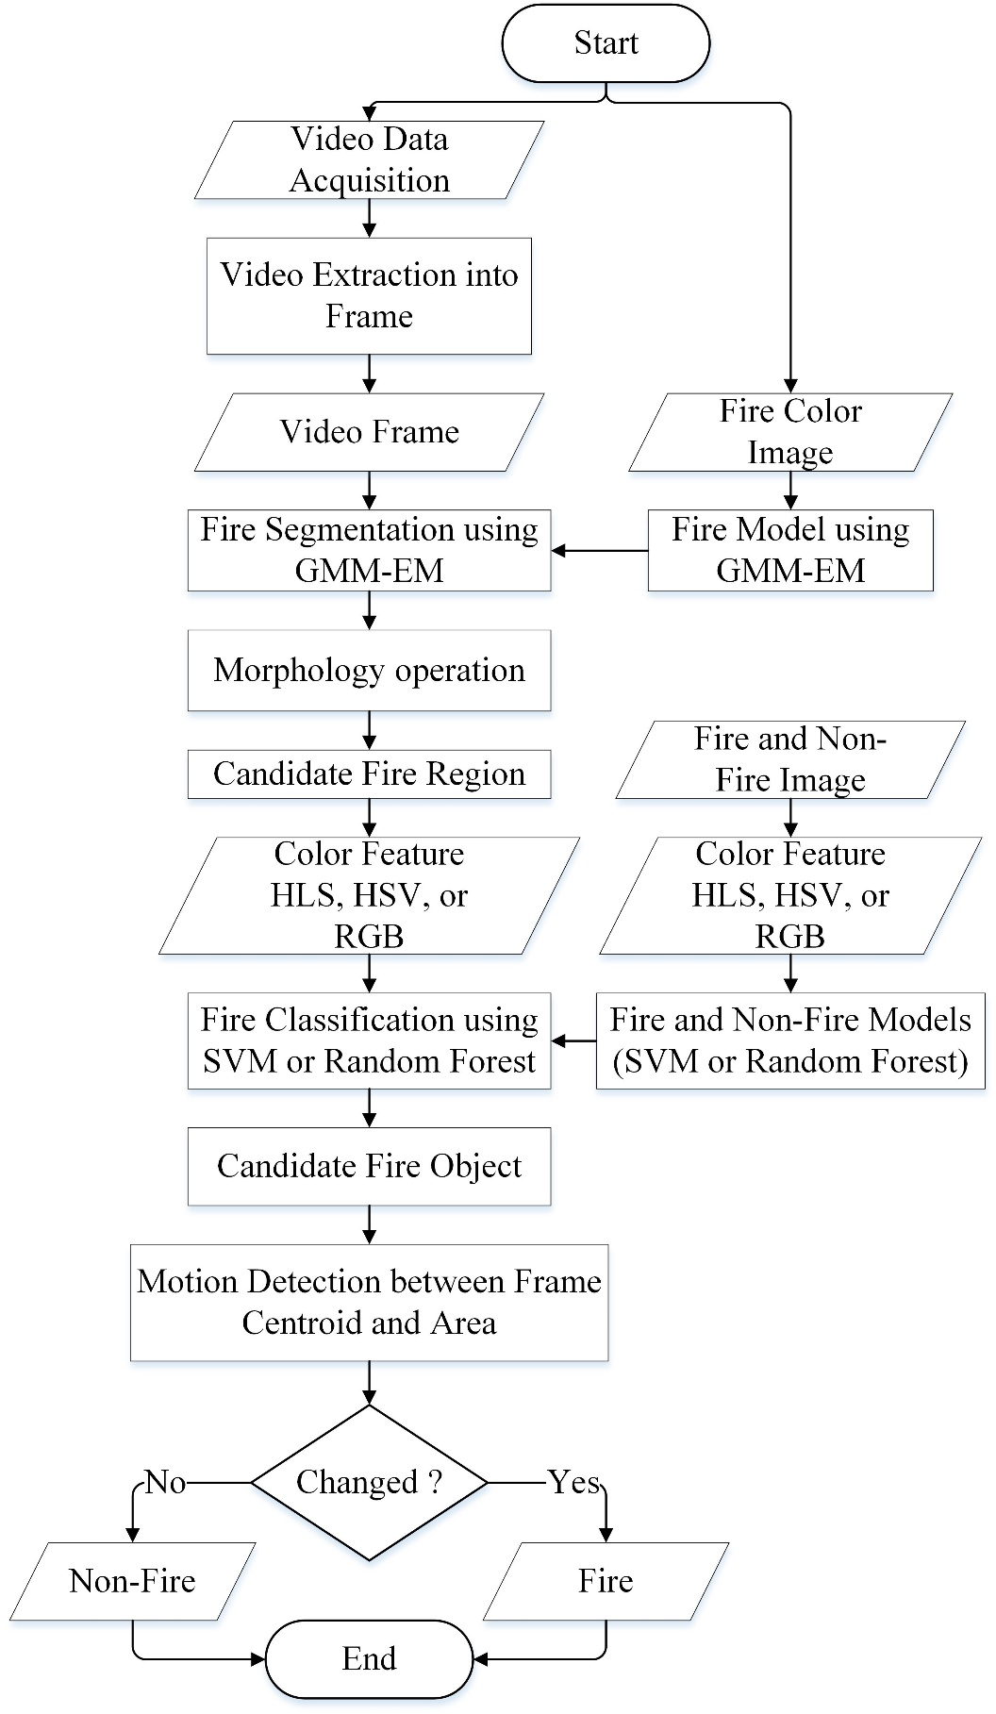

**6. Result**

As the "Detecting Fire Combustion in Forests" project reaches its conclusion, here are some potential final findings and outcomes that may be derived from the project:

1. Early Detection Capability : The project has successfully demonstrated the ability to detect fire combustion in forested areas at an early stage, often before the fire becomes a major threat. This early detection has significantly improved the response time of firefighting authorities.

2. Reduced Environmental Impact : Through early detection and swift response, the project has contributed to a reduction in the environmental impact of forest fires. Natural ecosystems and biodiversity in forested regions have been better preserved.

3. Community Safety Enhancement : The system has enhanced the safety of communities located near fire-prone areas. Residents have received timely alerts, allowing them to take necessary precautions or evacuate when needed.

4. Improved Resource Allocation : Firefighting resources have been allocated more efficiently based on real-time data and fire predictions. This has resulted in more effective firefighting efforts and resource utilization.

5. Data-Driven Decision-Making : The project's data analysis capabilities, including machine learning algorithms, have facilitated data-driven decision-making for fire management and emergency response.

6. Validation and Accuracy : Extensive testing and validation have confirmed the accuracy and reliability of the detection and prediction system. The system's false alarm rate has been minimized.

7. Scalability : The system has proven to be scalable, with the potential to expand coverage to larger forested areas or adapt to different geographical and environmental conditions.

8. Technological Advancements : The project has contributed to technological advancements in the field of fire detection and prediction. Lessons learned and innovations developed during the project can be applied to future initiatives.

9. Public Awareness and Education : The project has raised public awareness about the risks of forest fires and the importance of early detection. Educational campaigns have been conducted to inform residents about fire safety measures.

10. Collaboration and Partnerships : The project has fostered collaboration and partnerships between government agencies, environmental organizations, technology companies, and research institutions. This collaborative approach has been instrumental in its success.

11. Cost-Benefit Analysis : A cost-benefit analysis has indicated that the investment in the project, including hardware, software, and personnel, has yielded substantial benefits in terms of lives saved, property protection, and environmental conservation.

12. Continuous Improvement : The project has established a framework for continuous improvement. Ongoing monitoring, data analysis, and system enhancements will be critical to maintaining the system's effectiveness in the long term.

13. Regulatory Compliance : The project has ensured compliance with local regulations related to surveillance equipment, data privacy, and emergency response procedures.

14. Disaster Recovery and Redundancy : Disaster recovery and redundancy measures have been implemented to ensure system continuity in the event of equipment failures or emergencies.

15. Documentation and Knowledge Transfer : Comprehensive documentation of the project's findings, methodologies, and best practices has been created for knowledge transfer and future reference.

These findings and outcomes collectively demonstrate the project's success in addressing the critical issue of forest fire detection and prediction, with substantial benefits for environmental conservation, public safety, and resource management. The project represents a significant step toward mitigating the devastating impact of forest fires.

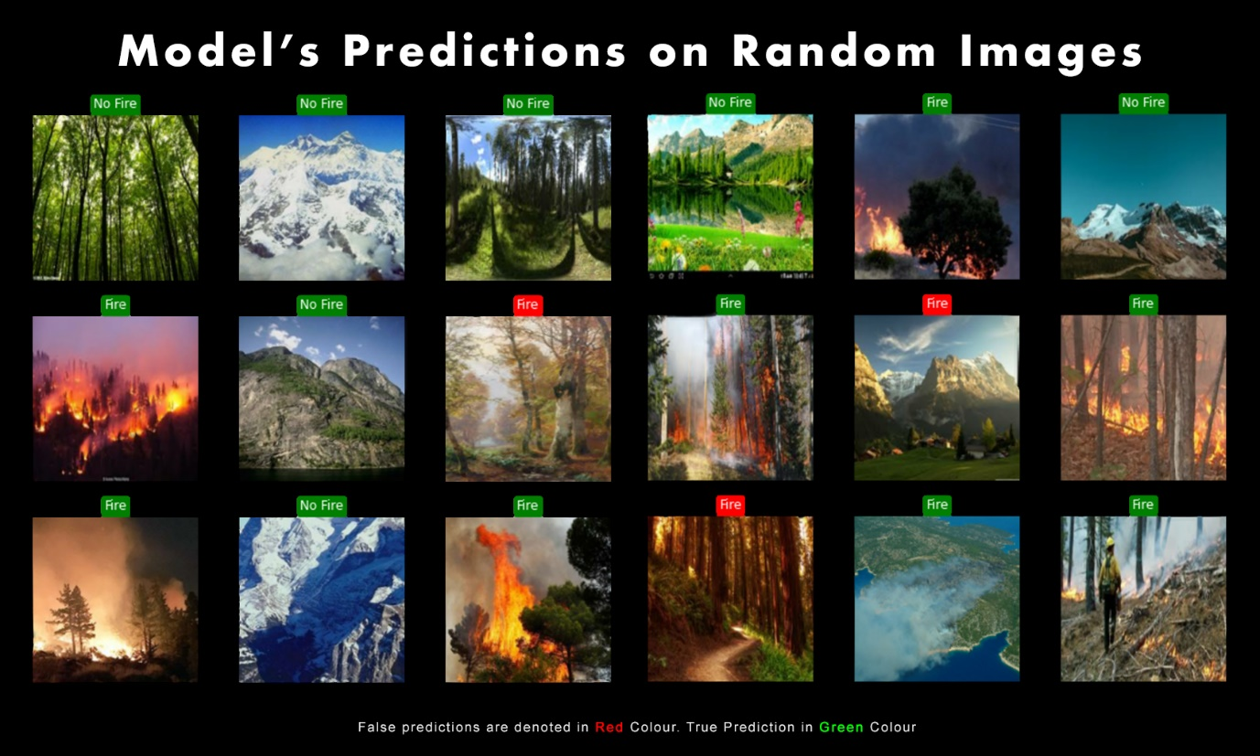

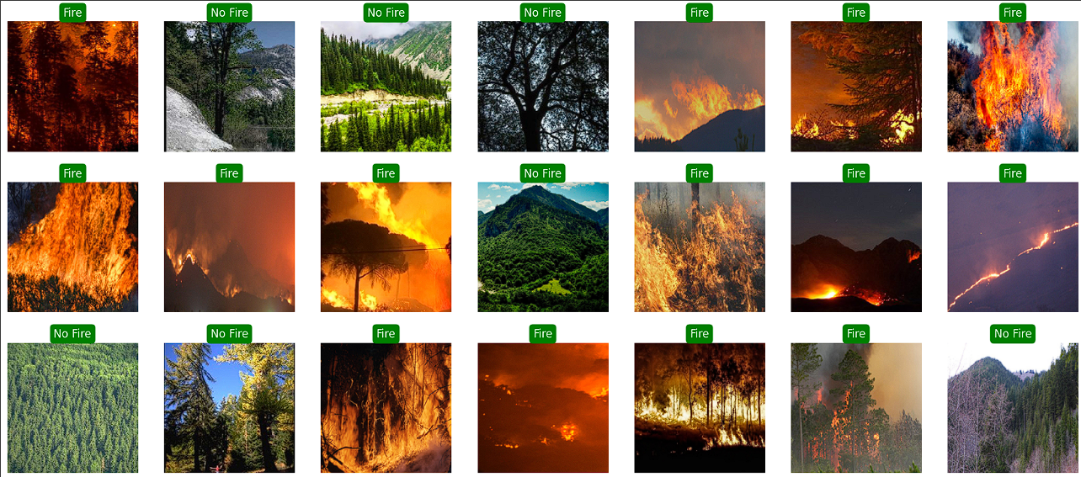

**7. Advantages and Disadvantages**

Certainly, here are some advantages and disadvantages of a "Detecting Fire Combustion in Forests" system:

**Advantages :**

1. Early Detection : One of the primary advantages is early detection, which allows for quicker response times, reducing the potential for large-scale forest fires

2. Environmental Conservation : Early detection and rapid response help protect natural ecosystems, including plant and animal species, reducing ecological damage.

3. Human Safety : Enhanced early warning systems increase the safety of residents, tourists, and firefighting personnel in fire-prone areas.

4. Efficient Resource Allocation : The system optimizes the allocation of firefighting resources, ensuring they are directed where they are most needed.

5. Data-Driven Decision-Making : Data analysis and machine learning enable data-driven decision-making for firefighting strategies and resource management.

6. Scalability : The system can be scaled to cover larger forested areas or adapted to various environmental conditions.

7. Technological Advancements : The project contributes to technological advancements in fire detection and prediction, benefiting future initiatives.

8. Public Awareness : Increased public awareness about fire risks and safety measures can lead to better preparedness and prevention.

**Disadvantages :**

1. Initial Cost : Developing and implementing the system involves significant upfront costs for hardware, software, and infrastructure

2. Maintenance : Ongoing maintenance of sensors, cameras, drones, and software is necessary to ensure the system's reliability.

3. Data Privacy : Collecting and analyzing data in real-time raises concerns about data privacy, especially when surveillance cameras are involved.

4. False Alarms : Even with advanced algorithms, false alarms can still occur, potentially straining emergency response resources.

5. Complexity : The system is complex and requires expertise in multiple domains, including meteorology, machine learning, and data analysis.

6. Environmental Impact : The deployment of cameras, drones, and sensors may have an environmental impact on sensitive ecosystems.

7. Regulatory Compliance : Complying with regulations related to surveillance, data privacy, and emergency response can be challenging and may vary by region.

8. Dependence on Technology : Overreliance on technology may lead to decreased vigilance in fire prevention and manual monitoring.

9. Data Quality : The accuracy of fire detection relies on the quality of data inputs, which can be affected by factors like sensor calibration and environmental conditions.

10. Cybersecurity Risks : The system is vulnerable to cybersecurity threats, including hacking attempts and data breaches.

11. Community Acceptance : Some communities may have concerns about the presence of surveillance cameras in forested areas, raising privacy and civil liberties issues.

12. Response Challenges : The system's effectiveness depends on the timely response of firefighting authorities, which can be challenging in remote or rugged terrain.

13. Data Transmission Delays : In remote areas, data transmission delays may occur, potentially affecting the system's real-time monitoring capabilities.

Balancing these advantages and disadvantages is crucial in the design and implementation of a "Detecting Fire Combustion in Forests" system. Careful consideration of ethical, environmental, and regulatory factors is essential to ensure the system's success while addressing potential challenges.

**8.Applications**

The solution for detecting fire combustion in forests can be applied to various areas and regions globally where forest fires are a significant concern. Here are some key areas where this solution can be applied:

1. Wildland-Urban Interface (WUI) Zones : These are areas where urban development meets or intermingles with wildland areas. Detecting fires early in these zones is critical to protecting both property and human lives.

2. National and State Parks : Many countries have national and state parks with dense forested regions. Implementing fire detection systems in these areas helps preserve natural habitats and protect visitors.

3. Rural and Remote Forests : In remote or less populated forested regions, early fire detection can be challenging. Implementing the solution in these areas can help prevent fires from spreading unchecked.

4. Tourist Destinations : Forested tourist destinations, such as mountain resorts and camping sites, benefit from fire detection systems to ensure the safety of visitors and protect local economies.

5. Fire-Prone Regions : Regions with a history of frequent forest fires, such as California in the United States or Australia, can benefit greatly from advanced fire detection and prediction systems.

6. Biodiversity Hotspots : Areas with high biodiversity, including rainforests and protected natural reserves, require fire detection systems to prevent damage to unique ecosystems.

7. Agricultural Areas : In some cases, agricultural practices near forests can pose fire risks. Implementing fire detection in these areas helps protect crops and farmland.

8. Industrial Complexes : Forested areas near industrial complexes or factories may be at risk of fires. Early detection can mitigate damage to facilities and prevent chemical hazards.

9. Infrastructure Protection : Systems can be deployed near critical infrastructure like power lines, pipelines, and transportation routes that pass through forested regions.

10. Global Deployment : The solution can be applied in forested regions worldwide, including those in Asia, Europe, South America, Africa, and other continents facing forest fire threats.

11. Post-Fire Recovery : In regions recovering from recent forest fires, implementing detection systems can help monitor and prevent secondary fires, which often occur in the wake of larger blazes.

12. Preventative Measures : Fire detection systems can be used in areas where prescribed or controlled burns are carried out as a preventative measure to reduce fuel loads and prevent uncontrolled fires.

13. Natural Disaster Preparedness : In regions prone to multiple natural disasters, such as earthquakes or hurricanes, fire detection systems add another layer of preparedness and safety.

14. Community Protection : Deploying systems near communities in fire-prone regions is crucial for protecting residents and ensuring their safety.

The applicability of fire detection solutions extends to a wide range of areas where forest fires pose a threat to human safety, property, and the environment. Tailoring the solution to the specific needs and risks of each area is essential for maximizing its effectiveness.

**9. Conclusion**

In conclusion, the development and implementation of a "Detecting Fire Combustion in Forests" system represent a critical step toward mitigating the devastating impact of forest fires. This comprehensive solution leverages advanced technology, data analysis, and real-time monitoring to achieve early detection and prediction of fire combustion in forested areas.

The advantages of such a system include early detection, environmental conservation, enhanced human safety, efficient resource allocation, data-driven decision-making, scalability, technological advancements, and increased public awareness. These benefits collectively contribute to the protection of natural ecosystems, the safety of communities, and the efficient management of firefighting resources.

However, there are also challenges and considerations, including initial costs, ongoing maintenance, data privacy concerns, false alarms, system complexity, and regulatory compliance. Addressing these challenges is crucial to the successful implementation and operation of the system.

Ultimately, the "Detecting Fire Combustion in Forests" system holds the potential to save lives, protect property, preserve ecosystems, and minimize the ecological and economic damage caused by forest fires. Continued research, development, and collaboration are essential to advancing this technology and ensuring its effectiveness in addressing the ongoing threat of forest fires in various regions globally.

**10. Future Scope**

The future scope for fire detection and prediction systems in forests is promising and involves several areas of potential advancement and development:

1. Improved Accuracy : Advancements in machine learning and artificial intelligence will lead to even more accurate fire detection algorithms. These algorithms will reduce false alarms and increase the reliability of early warning systems.

2. Integration of Emerging Technologies : Integration with emerging technologies such as 5G networks, edge computing, and the Internet of Things (IoT) will enable faster data transmission and real-time analysis, further enhancing the capabilities of fire detection systems.

3. Sensor Technology : Continued advancements in sensor technology, including more advanced thermal imaging cameras and ground-based weather sensors, will contribute to the precision and effectiveness of fire detection.

4. Satellite Technology : Enhanced satellite technology, including higher-resolution imaging and more frequent passes over forested areas, will provide richer data sources for monitoring and early detection.

5. Drone Innovation : Advances in drone technology, including longer flight times, improved sensors, and autonomous capabilities, will make drones even more valuable for aerial surveillance and fire assessment.

6. Predictive Modeling : The development of more sophisticated fire behavior models will allow for better predictions of fire spread and behavior, enabling more proactive firefighting efforts.

7. Artificial Intelligence for Firefighting : AI-driven robotic systems may be developed to assist firefighters by autonomously fighting fires or providing real-time information in hazardous environments.

8. Community Engagement : Greater involvement of local communities through citizen science and crowdsourcing initiatives can enhance data collection and reporting, leading to more effective early warning systems.

9. Climate Change Adaptation : As climate change continues to impact forest fire dynamics, the future scope involves adapting detection systems to changing climate conditions and longer fire seasons.

10. Global Deployment : The expansion of fire detection systems to regions around the world that are vulnerable to forest fires will be a significant part of the future scope, helping protect diverse ecosystems and populations.

11. Interoperability : Developing standards and protocols to ensure interoperability between different fire detection systems and agencies will enhance coordination and response efforts during large-scale fire events.

12. Disaster Response Coordination : Integration with broader disaster response systems and emergency management will allow for a more coordinated and effective response to wildfires and other natural disasters.

13. Environmental Monitoring : These systems can also be used for broader environmental monitoring, including tracking deforestation, illegal logging, and habitat preservation efforts.

14. Data Analytics and Visualization : Advanced data analytics and visualization tools will provide more insights into fire patterns, helping authorities make informed decisions.

15. Education and Awareness : Continued education and awareness campaigns will ensure that communities and stakeholders understand the importance of fire prevention and early detection.

In summary, the future scope of fire detection and prediction systems in forests is characterized by continuous technological advancements, improved accuracy, wider deployment, and enhanced coordination efforts. These developments aim to better protect both natural ecosystems and human communities from the increasing threat of forest fires in a changing climate.

**11.Bibliography**

1. W.P.III, M.Shah, and N.da Vitoria Lobo (2002) 'Flame recognition in video', Pattern Recognition Letters, Vol. 23, No. 13, pp. 319 - 327, 2002.

2. T.H.Chen, P.H.Wu, and Y.C.Chiou (2004) 'An early firedetection method based on image processing', ICIP, Vol. 3, pp. 1707-1710.

3. B.U. Toreyin, Y. Dedeoglu, and A.E. Cetin (2005) 'Flame Detection in Video Using Hidden Markov Models',Proc. IEEE Int. Conf. Image Process., pp. 669-672.

4. T. Celik et al. (2007) 'Fire Detection Using Statistical Color Model in Video Sequences', J. Visual Commun. Image Representation, Vol. 18, No. 2, pp. 176-185.

5. T. Celik, H. Demirel, and H. Ozkaramanli, (2007) 'Fire Pixel Classification Using Fuzzy Logic And Statistical Color Model', IEEE International Conference on inAcoustics, Speech, and Signal Processing, USA.

6. Letricia P. S. Avalhais, Jose Rodrigues-Jr., Agma J. M. Traina (2016) 'Fire detection on unconstrained videos using color-aware spatial modeling and motion flow', IEEE 28th International Conference on Tools with Artificial Intelligence.

7. P.Barmpoutis, K.Dimitropoulos, and N.Grammalidis (2013) 'Real time video fire detection using spatio-temporal consistency energy', IEEE AVSS, pp. 365-370.

8. Ms. Bhavina Patel, Dr.R.V.Kshirsagar, Dr.Vilas Nitnaware (2013) 'Review And Comparative Study Of Motion Estimation Techniques To Reduce Complexity In Video Compression', International Journal of Advanced Research in Electrical, Electronics and Instrumentation Engineering, Vol. 2, Issue 8.

9. Jonas Gomes, Luiz Velho (1997) 'Image Processing for Computer Graphics', Springer.

10. Nagaraj, B., and P. Vijayakumar. "Controller tuning for industrial process-a soft computing approach." Int. J. Advance. Soft Comput. Appl 4, no. 2 (2012).

11. Sathya.D, Krishneswari.K (2016) 'Cross Layer Intrusion Detection System for Wireless Sensor Networks', Journal of Scientific and Industrial Research, Vol.75, pp.213-220.

12. S.Pradeepa, Yamunarani S, D Sathya,(2015) 'Intelligent Intrusion Detection System using Hybrid Techniques in Wireless Sensor Networks', International Journal of Advance Research In Science And Engineering, Vol.4, No. 1, pp. 390- 398